VITYARTHI PROJECT REPORT
Name: Rabnoor Kaur Bhatia Faculty: Ashfaq Ahmad Najar
Reg. No.: 25BCE10566 Date: 30th March 2026
CHATBOT

1. Aim
The aim of this project is to create a simple chatbot using Python that can interact with users by responding to basic messages like greetings, questions, and commands.

2. Why This Project Matters
Chatbots are widely used today in websites, apps, and customer service systems. They help users get quick responses without human involvement.
This project is important because:
- It helps understand how conversations between humans and computers work
- It builds a foundation for more advanced AI systems
- It improves programming and logical thinking skills
- It introduces real-world applications of coding

3. Approach to Solve the Problem
To solve the problem:
- I created a chatbot that takes user input using Python
- The input is converted to lowercase to avoid case issues
- I used if-elif-else conditions to check for keywords
- Based on the keywords, the chatbot gives predefined responses
- A loop (while True) keeps the chatbot running until the user exits
4. Code
# Simple Chatbot
print("Chatbot: Hi! Type 'bye' to exit.")
while True:
user = input("You: ").lower()
if user == "bye":
print("Chatbot: Goodbye!")
break

elif "hello" in user or "hi" in user:
print("Chatbot: Hello there!")

elif "how are you" in user:
print("Chatbot: I'm just code, but I'm doing great!")

elif "your name" in user:
print("Chatbot: I'm a simple Python chatbot.")

elif "help" in user:
print("Chatbot: You can say hello, ask my name, or say bye.")

else:
print("Chatbot: Sorry, I don't understand that.")

5. Output
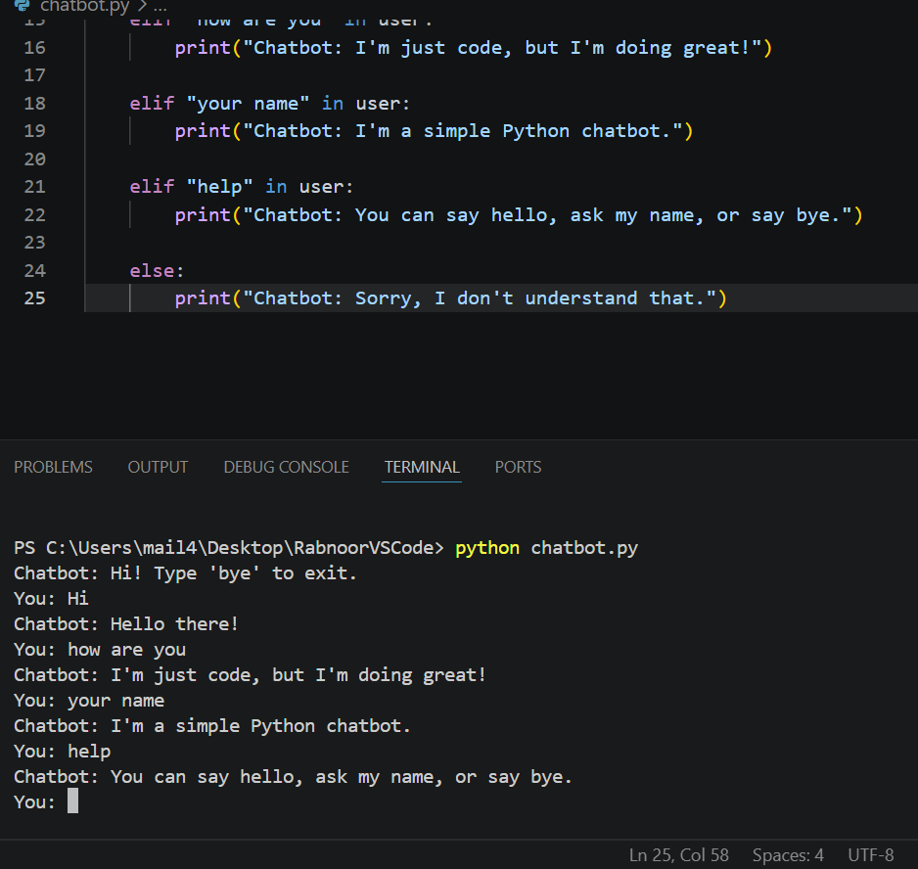

6. Key Decisions Made
While developing the chatbot, I made some important decisions:
- Using keyword matching instead of exact sentences
This allows flexibility in user input
- Using .lower() function
Ensures the chatbot works regardless of uppercase or lowercase input
- Using an infinite loop (while True)
Keeps the chatbot active until the user types "bye"
- Adding a default response
Handles unknown inputs without crashing

7. Challenges Faced
During the development of this project, I faced several challenges:
- Handling different variations of user input
- Making sure the chatbot doesn’t break for unexpected inputs
- Keeping responses simple but meaningful
- Managing multiple conditions without confusion

8. What I Learned
From this project, I learned:
- How chatbots work at a basic level
- How to use loops and conditional statements effectively
- How to handle and process user input in Python
- The limitations of rule-based systems
- The importance of planning logic before coding

9. Conclusion
This project helped me understand the basics of chatbot development. Although it is simple, it shows how a program can interact with users.
It also gave me a strong base to explore more advanced technologies in the future.

THANK YOU

